**Lembar Jawaban Kalkulasi Neural Network**

**Pada lembar jawaban ini, kamu dapat menuliskan cara mengkalkulasikan nilai-nilai yang diminta pada arsitektur neural network sesuai soal beserta hasilnya, ya, semangat!😄**

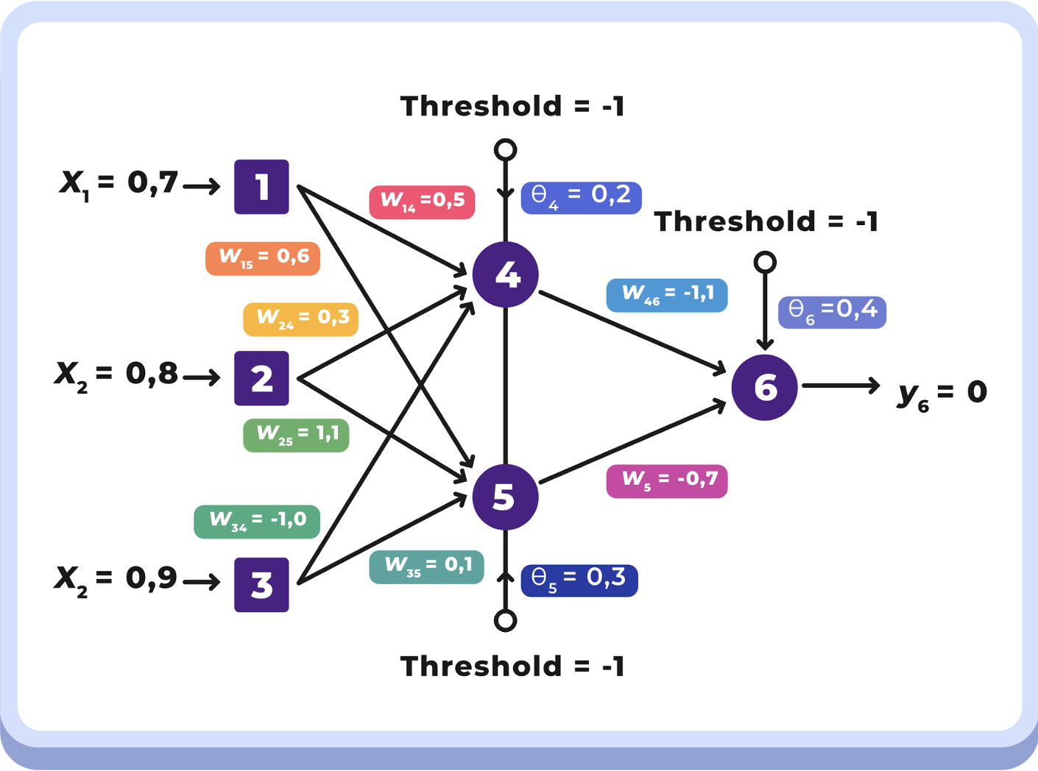

Pertama, masukkan dulu nilai initial value dan initial randomnya ya …

**Initial Value**

|  |  |  |  |  |  |
| --- | --- | --- | --- | --- | --- |
| **x1** | **x2** | **x3** | **α** | **Threshold** | **Yd,6** |
| **0.7** | **0.8** | **0.9** | **0.1** | **-1** | **0** |

**Initial Random**

|  |  |  |  |  |  |  |  |  |  |  |
| --- | --- | --- | --- | --- | --- | --- | --- | --- | --- | --- |
| **W14** | **W15** | **W24** | **W25** | **W34** | **W35** | **W46** | **W56** | **θ4** | **θ5** | **θ6** |
| **0.5** | **0.6** | **0.3** | **1.1** | **-1.0** | **0.1** | **-1.1** | **-0.7** | **0.2** | **0.3** | **0.4** |

Jika sudah selesai, kita akan masuk ke langkah-langkah kalkulasi, sebagai berikut:

**Forward Pass**

Forward Pass merupakan hasil dari langkah 1 pada proses kalkulasi di challenge deck. Oleh karena itu kamu tuliskan langkah kalkulasi yang kamu lakukan untuk mencari nilai-nilai di bawah ini, ya🙌

**Langkah 1: Menghitung output Neuron 4 (y4), Neuron 5 (y5), Neuron 6 (y6), dan Error menggunakan sigmoid function**

|  |  |
| --- | --- |
| Y4 | = Sigmoid (X1 * W14 + X2 * W24 + X3 * W34 -θ4) |
|  | = 1 / [1 + e-(0.7*0.5 + 0.8*0.3 + 0.9 * -1.0 – 1 * 0.2)] |
|  | = 0.3752 |
| Y5 | = Sigmoid (X1 * W15 + X2 * W25 + X3 * W35 - θ5) |
|  | = 1 / [1 + e-(0.7*0.6 + 0.8*1.1 + 0.9 * 0.1 – 1 * 0.3)] |
|  | = 0.7484 |
| Y6 | = Sigmoid (Y4 * W46 + Y5 * W56 -1 * θ6) |
|  | = 1 / [1 + e-(0.3752*-1.1 + 0.7484*-0.7 – 1 * 0.4)] |
|  | = 0.2081 |
| e | = Yd,6 – Y6 |
|  | = 0 – 0.2081 |
|  | = - 0.2081 |

Lalu isi rangkuman hasilnya di tabel ini ya …

|  |  |  |  |
| --- | --- | --- | --- |
| **Y4** | **Y5** | **Y6** | **e** |
| **0.3752** | **0.7484** | **0.2081** | **-0.2081** |

**Backward Pass**

Sementara itu, nilai-nilai dari backward pass didapatkan dengan menjalankan langkah 2, 3, dan 4. Jangan lupa tuliskan proses dan hasil kalkulasinya pada tempat yang telah disediakan di bawah, ya👍

**Langkah 2: Hitung error gradient untuk Neuron 6 di Output Layer dan weight corrections**

|  |  |
| --- | --- |
| δ6 | = Y6 (1-Y6)e |
|  | = 0.2081 * (1-0.2081) * - 0.2081 |
|  | = -0.0343 |
| ∇46 | = α * Y4 * δ6 |
|  | = 0.1 * 0.3752 * -0.0343 |
|  | = -0.0013 |
| ∇56 | = α * Y5 * δ6 |
|  | = 0.1 * 0.7484 * -0.0343 |
|  | = -0.0026 |
| ∇θ6 | = α * -1 * δ6 |
|  | = 0.1 * -1 * -0.0343 |
|  | = 0.0034 |

Lalu isi rangkuman hasilnya di tabel ini ya …

|  |  |  |  |
| --- | --- | --- | --- |
| **δ6** | **∇46** | **∇56** | **∇θ6** |
| **-0.0343** | **-0.0013** | **-0.0026** | **0.0034** |

**Langkah 3: Hitung error gradients untuk Neuron 4 dan Neuron 5 di Middle Layer/Hidden Layer**

|  |  |
| --- | --- |
| δ4 | = Y4 (1-Y4) * δ6 * W46 |
|  | = 0.3752 * (1-0.3752) * -0.0343 * -1.1 |
|  | = 0.0088 |
| δ5 | = Y5 (1-Y5) * δ6 * W56 |
|  | = 0.7484 * (1-0.7484) * -0.0343 * -0.7 |
|  | = 0.0045 |

Lalu isi rangkuman hasilnya di tabel ini ya …

|  |  |
| --- | --- |
| **δ4** | **δ5** |
| **0.0088** | **0.0045** |

**Langkah 4: Hitung weight corrections**

|  |  |
| --- | --- |
| ∇w14 | = α * X1 * δ4 |
|  | = 0.1 * 0.7 * 0.0088 |
|  | = 0.0006 |
| ∇w24 | = α * X2 * δ4 |
|  | = 0.1 * 0.8 * 0.0088 |
|  | = 0.0007 |
| ∇w34 | = α * X3 * δ4 |
|  | = 0.1 * 0.9 * 0.0088 |
|  | = 0.0008 |
| ∇θ4 | = α * -1 * δ4 |
|  | = 0.1 * -1 * 0.0088 |
|  | = -0.0009 |
| ∇w15 | = α * X1 * δ5 |
|  | = 0.1 * 0.7 * 0.0045 |
|  | = 0.0003 |
| ∇w25 | = α * X2* δ5 |
|  | = 0.1 * 0.8 * 0.0045 |
|  | = 0.0004 |
| ∇w35 | = α * X3* δ5 |
|  | = 0.1 * 0.9 * 0.0045 |
|  | = 0.0004 |
| ∇θ5 | = α * -1 * δ5 |
|  | = 0.1 * -1 * 0.0045 |
|  | = - 0.0005 |

Lalu isi rangkuman hasilnya di tabel ini ya …

|  |  |  |  |  |  |  |  |
| --- | --- | --- | --- | --- | --- | --- | --- |
| **∇w14** | **∇w24** | **∇w34** | **∇θ4** | **∇w15** | **∇w25** | **∇w35** | **∇θ5** |
| **0.0006** | **0.0007** | **0.0008** | **-0.0009** | **0.0003** | **0.0004** | **0.0004** | **-0.0005** |

**Backward Pass**

Last but not least, adalah nilai-nilai dari updated weight didapatkan dengan menjalankan langkah nomor 5. Seperti biasa, tuliskan proses dan hasil kalkulasinya pada tempat yang telah disediakan di bawah, ya👌

**Langkah 5: Hitung semua weights dan theta pada arsitektur yang telah diperbarui**

|  |  |
| --- | --- |
| w14 | = W14 + ΔW14 |
|  | = 0.5 + 0.0006 |
|  | = 0.5006 |
| w15 | = W15 + ΔW15 |
|  | = 0.6 + 0.0003 |
|  | = 0.6003 |
| w24 | = W24 + ΔW24 |
|  | = 0.3 + 0.0007 |
|  | = 0.3007 |
| w25 | = W25 + ΔW25 |
|  | = 1.1 + 0.0004 |
|  | = 1.1004 |
| w34 | = W25 + ΔW34 |
|  | = -1.0 + 0.0008 |
|  | = -0.9992 |
| w35 | = W35 + ΔW35 |
|  | = 0.1 + 0.0004 |
|  | = 0.1004 |
| θ4 | = θ4 + Δθ4 |
|  | = 0.2 + -0.0009 |
|  | = 0.1991 |
| θ5 | = θ5 + Δθ5 |
|  | = 0.3 + -0.0005 |
|  | = 0.2995 |
| θ6 | = θ6 + Δθ6 |
|  | = 0.4 + 0.0034 |
|  | = 0.4034 |

Lalu isi rangkuman hasilnya di tabel ini ya …

|  |  |  |  |  |  |  |  |  |
| --- | --- | --- | --- | --- | --- | --- | --- | --- |
| **w14** | **w15** | **w24** | **w25** | **w34** | **w35** | **Θ4** | **Θ5** | **Θ6** |
| **0.5006** | **0.6003** | **0.3007** | **1.1004** | **-0.9992** | **0.1004** | **0.1991** | **0.2995** | **0.4034** |

**Hore, kamu sudah menyelesaikan satu dari tiga proyek challenge platinum! Semoga mendapatkan hasil yang maksimal dan selamat bersenang-senang~**